**USKUDAR UNIVERSITY**

**FACULTY OF ENGINEERING AND NATURAL SCIENCES**

**DEPARTMENT OF SOFTWARE ENGINEERING**

**COME 102 – INTRODUCTION TO ALGORITHMS AND PROGRAMMING**

**LAB SHEET - 1**

**QUESTION 1**

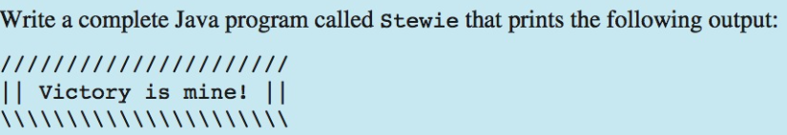

**QUESTION 2**

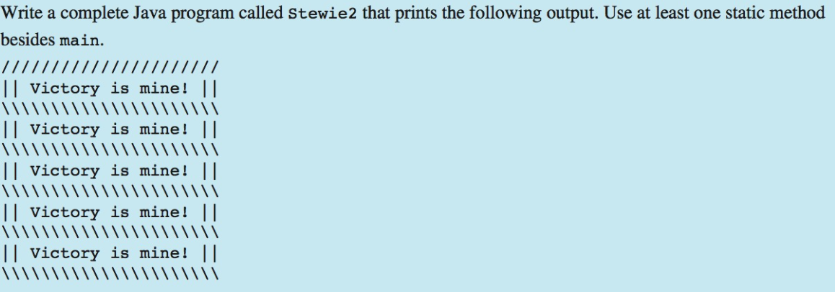

**QUESTION 3**

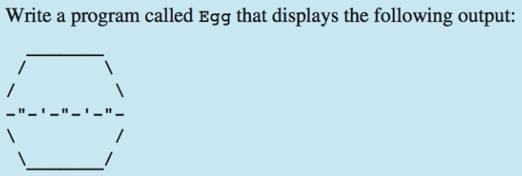

**QUESTION 4**

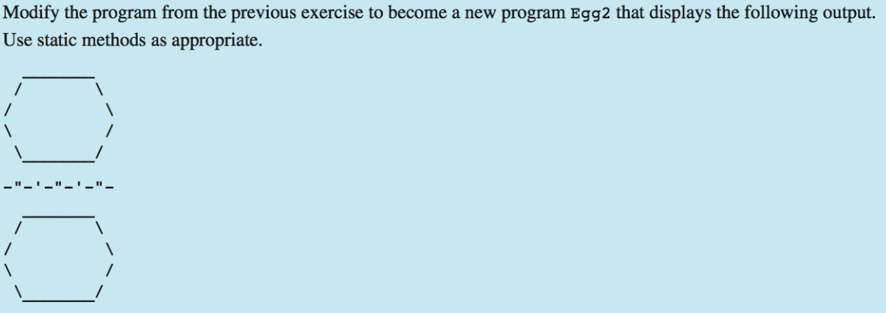

**CHALLENGE! ☺**

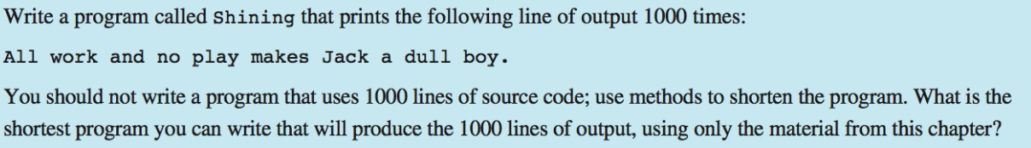

**YOU CAN FIND MORE EXERCISES AT THE END OF CHAPTER 1 OF COURSE TEXT BOOK!**

**(BUILDING JAVA PROGRAMS BY STUART REGES MARTY STEPP)**